Teacher’s Guide

Module 5. The Internet as an Information Resource

Lesson 1. How the Internet works

 | Note  The Teacher’s Guide provides notes and tips for the PowerPoint presentation that you will use in conducting the course.

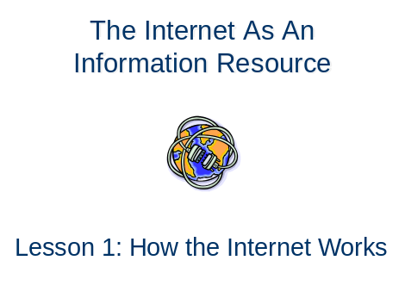
Slide 1

 | Tip  Ask the students what their concept of the Internet is and if any of them have used it before and for what purpose. After that, ask them if they have an idea of how the Internet works. This can serve as a motivation activity that will let them think ahead, and share their knowledge and experiences with regards to the subject matter, with you and their fellow students.

Slide 2
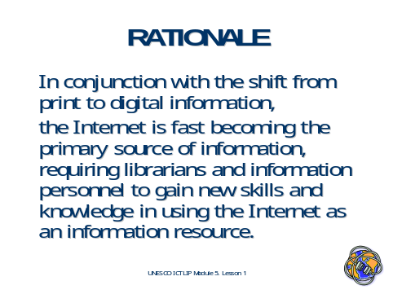

Rationale

In Asia many librarians have not obtained adequate training in the use of the Internet as an information resource. However, with the shift from printed to digital format, as well as a lot of users and researchers becoming more and more reliant on the Internet as an information resource, it is imperative that librarians obtain adequate training in its use in order for them to cope with the challenges and take advantage of the features of the Internet.

Slide 3
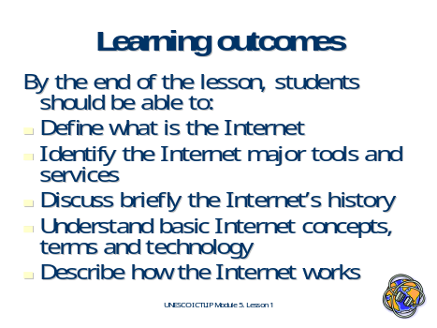

Learning outcomes

By the end of the lesson, students should be able to:
- Define what is the Internet
- Identify the major Internet tools and services
- Discuss briefly the Internet's history
- Understand basic Internet concepts, terms and technology
- Describe how the Internet works

Slide 4
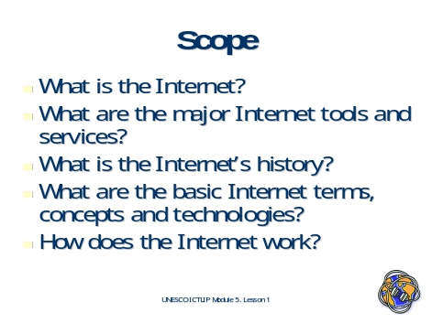

Scope

- What is the Internet?
- What are the major Internet Tools and services?
- What is the Internet’s history?
- What are the basic Internet concepts, terms and technologies?
- How does the Internet work?
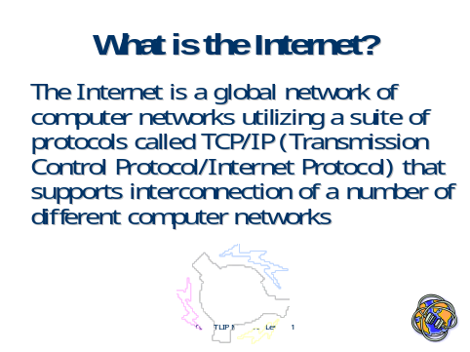
Slide 5

What is the Internet?

The Internet is a global network of computer networks utilizing a suite of protocols called the TCP/IP (Transmission Control Protocol/Internet Protocol) that supports interconnection of a number of different computer networks.

Slide 6
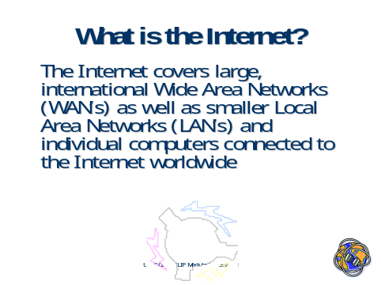

The Internet covers large, international Wide Area Networks (WAN’s) as well as smaller Local Area Networks (LAN’s) and individual computers connected to the Internet worldwide

Slide 7
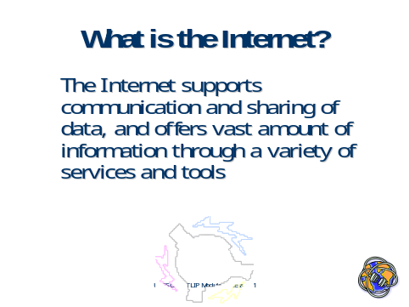

The Internet supports communication and sharing of data, and offers a vast amount of information through a variety of services and tools

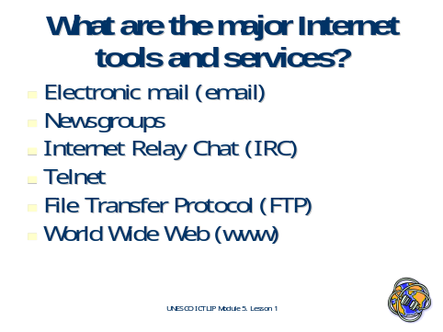
Slide 8

What are the major Internet tools and services?

The Internet has several tools and services that make it ideal as an information resource. Each of these features has its own merits and therefore should be utilized depending on the type of information one needs to access.

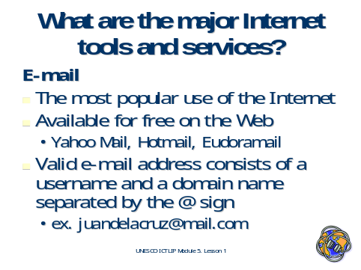
Slide 9

E-Mail

By far the most popular service available on the Internet, e-mail as a form of correspondence has revolutionalized the way we communicate with each other. It stands for “electronic mail, a way of sending messages from one computer to another. Its ability to send files through attachments also factors in its popularity. Readily available, and in most cases free of charge, this speedy alternative to postage mail comprises the bulk of traffic on the Internet. Almost all ‘Net users have at least one e-mail address, and in some cases, several addresses. It has also become the most basic form of identification on the Internet, with a lot of websites requiring an e-mail address before offering services.

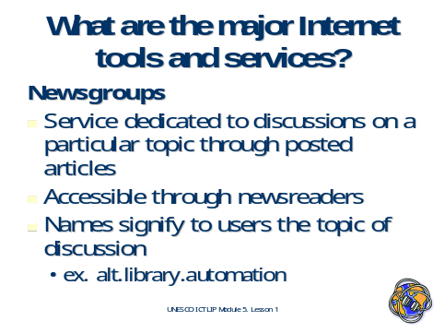
Slide 10

Newsgroups

Newsgroups are an online forum for discussion of related topics, accessible by a newsreader. Some newsgroups allow postings or messages from anyone; while others are moderated (postings are screened). Several university departments have also set up newsgroups for specific issues and class use. On the Internet, there are literally thousands of newsgroups covering every conceivable interest.

To view and post messages to a newsgroup, you need a newsreader, a program that runs on your computer and connects you to a news server on the Internet.

Slide 11
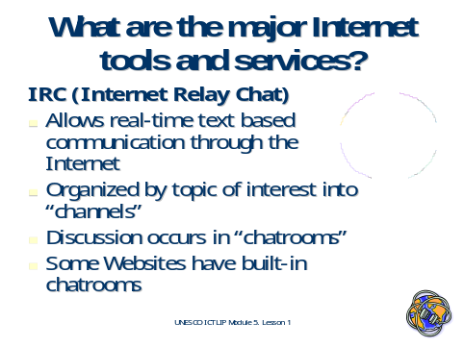

Internet Relay Chat

Using chat is like "talking" to other people who are online at the same time as you are. Special software allows typed-in messages to be viewed by everyone taking part at that time. Chats can be ongoing or scheduled for a particular time and duration. Most chats are focused on a particular topic of interest and some involve guest experts or famous people who "talk" to anyone joining the chat. Topics of interest are organized into “channels”, facilitating specialized chat sessions that occur in chatrooms. More advanced forms of chat use sound cards to allow voices, and 2D or 3D characters called “avatars” to represent the participants. Some websites have built in chatrooms enabling on-site chatting.

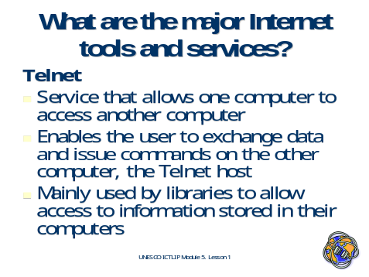
Slide 12

Telnet

Telnet is client software allowing a user to login from a local desktop computer to a remote server, the Telnet host, and use its resources. Usually access is controlled by passwords given to each individual or group. Once access is given, the remote user can issue commands or use the resources of the host, depending on the level of access given the user. Mainly used by libraries to allow access to information stored in their computers

Slide 13
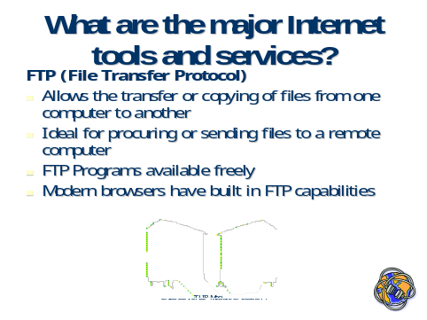

File Transfer Protocol

File Transfer Protocol or FTP is an Internet utility that allows the transfer of files from one location to another. In order to do this, one must have an FTP program to connect to other servers and be able to download files. These FTP programs are available both commercially and free, and offer various features. Most modern web browsers have built in FTP capabilities enabling downloads through websites.

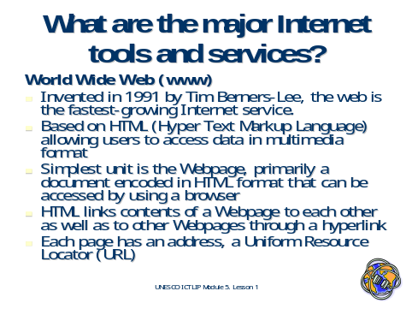
Slide 14

World Wide Web

The World Wide Web (WWW or W3) was invented by Tim Berners-Lee in 1991 and further developed at the CERN labs in Switzerland in the early 1990s. It is a vast collection of interconnected files and programs spanning the globe and retrievable via a client-server system utilizing HTML (Hyper Text Markup Language) enabled documents called webpages. It is responsible for the so called Internet boom, transforming it from a largely academic domain into a commercial one. It has grown to encompass not only its native http protocol, but also ftp, newsgroups, e-mails, chat and telnet. In fact, because of this most people equate the Web with the Internet .

The Web is accessed by programs called browsers (e.g., Netscape Navigator or Internet Explorer). These browsers enable webpages and websites containing multimedia content and applications to be accessed anytime, anywhere. Users navigate the Internet by following links from one document to other documents on computers located anywhere on the globe. These links are called hyperlinks, and connect the contents of Webpages to each other as well as to other Webpages identified by their URLs.

 | Activity 1-1  Visit the following sites:  - Learn the Net: The Animated Internet http://www.learnthenet.com/english/animate/animate.htm  - A Basic Guide to the Internet http://library.albany.edu/internet/internet.html

Tip
Visit these sites:
- Internet 101.org. Scott Cottingham. http://www.internet101.org/
- BBC Becoming WebWise Online Course for Beginners. http://www.bbc.co.uk/webwise/learn/menu.shtml
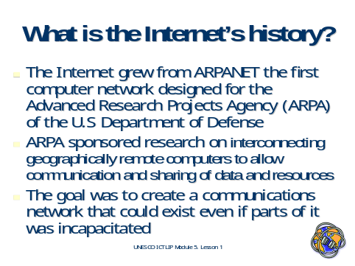
Slide 15

What is the Internet's History?

The Internet grew from ARPANET, the first computer network designed for the Advanced Research Projects Agency (ARPA) of the U.S Department of Defense. ARPA sponsored research on interconnecting geographically remote computers to allow communication and sharing of data and resources. The goal was to create a communications network that could exist even if parts of it were incapacitated.

Slide 16
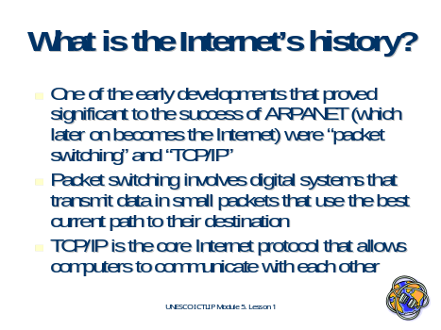

What is the Internet's History?

One of the early developments that proved significant to the success of ARPANET (which later on becomes the Internet) were “packet switching” and “TCP/IP”. Packet switching involves digital systems that transmit data in small packets that use the best current path to their destination. TCP/IP is the core Internet protocol that allows computers to communicate with each other.

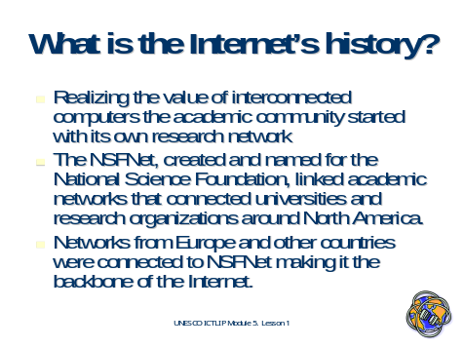
Slide 17

What is the Internet's History?

Realizing the value of interconnected computers the academic community started with its own research networks. One of these academic networks is NSFNET. NSFNET, created and named for the National Science Foundation, linked academic networks that connected universities and research organizations around North America. Later on, networks from Europe and other countries were connected to NSFNET, making it the backbone of the Internet.

Slide 18
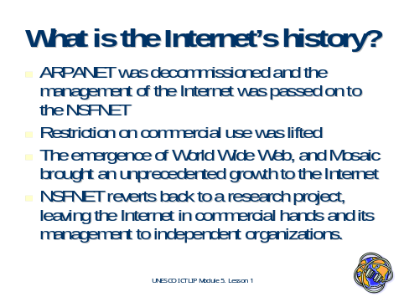

What is the Internet's History?

ARPANET was decommissioned and the management of the Internet was passed on to the NSFNET. NSFNET lifted the restriction on commercial use, which contributed to the Internet’s growth as well as to its commercialization. This significant development was followed by the emergence of the World Wide Web, and later on Mosaic, the first graphical browser, that brought an unprecedented growth to the Internet. Eventually, NSFNET reverted back to a research project, leaving the Internet in commercial hands and its management to independent organizations.

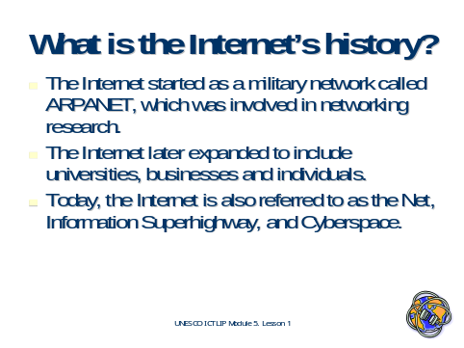
Slide 19

What is the Internet's History?

The Internet started as a military network called ARPANET, which was involved in networking research. The research involved the creation of standards and protocols that will support interconnection of a number of computer networks. It also involved the creation of applications and technologies that utilize current and emerging technologies. This process continues as the Internet grows dynamically.

The Internet later expanded to include universities, businesses and individuals. However, the Internet only started to gain popularity with the casual computer user in the 1990s, with the creation of the World Wide Web, followed by the introduction of Mosaic, the first graphical Web browser. Today, the Internet is also referred to as the Net, Information Superhighway, and Cyberspace.

Activity 1-2
Visit the following sites to know more about the Internet's history:
- A Brief History of the Internet and Related Networks. Vint Cerf. http://www.isoc.org/internet/history/cerf.shtml
- The History of the Internet. Dave Kristula. http://www.davesite.com/webstation/net-history.shtml

Tip
Read more about the Internet's History:
- All About The Internet: History of the Internet. Internet Society (ISOC). http://www.isoc.org/internet/history/brief.shtml
- History and Development of the Internet: a Timeline. Rhonda Davila. http://www.sat.lib.tx.us/Displays/itintro.htm
- The Living Internet. William Stewart. http://livinginternet.com/

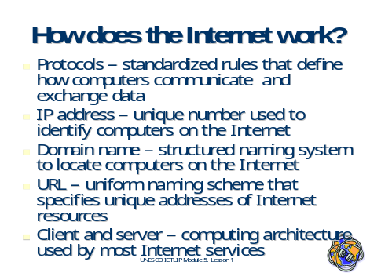
Slide 20

How does the Internet work?

The following are some of technologies that make the Internet work:
- Protocols – standardized rules that define how computers communicate and exchange data
- IP address – unique number used to identify computers on the Internet
- Domain name – structured naming system to locate computers on the Internet
- URL – uniform naming scheme that specifies unique addresses of Internet resources
- Client and server – computing architecture used by most Internet services

Slide 21
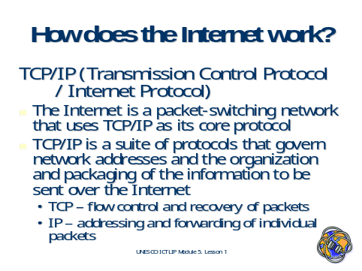

TCP/IP (Transmission Control Protocol / Internet Protocol)

The Internet is a packet-switching network that uses TCP/IP as its core protocol. TCP/IP is a suite of protocols that govern network addresses and the organization and packaging of the information to be sent over the Internet. Transmission Control Protocol (TCP) handles the flow control and recovery of packets, while Internet Protocol (IP) is responsible for addressing and forwarding of individual packets.

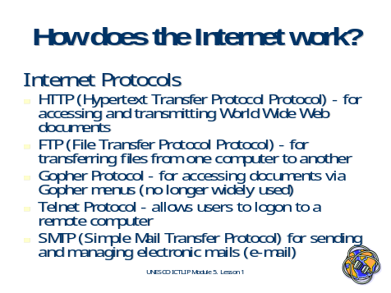
Slide 22

Internet Protocols

Below do Internet tools and services use some of the Internet Protocols:

- HTTP (Hypertext Transfer Protocol ) – a protocol for accessing and transmitting World Wide Web documents
- FTP (File Transfer Protocol) – a protocol for transferring files from one computer to another
- Gopher Protocol – a protocol for accessing documents via Gopher menus (no longer widely used)
- Telnet Protocol – a protocol that allows users to logon to a remote computer
- SMTP (Simple Mail Transfer Protocol) – a protocol for sending and managing electronic mails (e-mail)

Slide 23

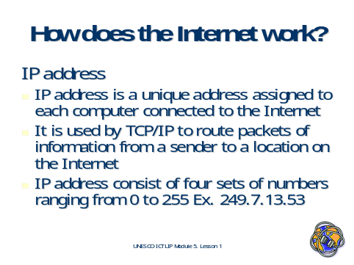

IP address

Unlike local computer networks, which are centrally controlled, the Internet is decentralized by design. Its operators can choose which Internet services to use and which services to make available to the global Internet community. Each Internet computer, called a host, is independent and has a unique address, called the IP address. TCP/IP uses the IP address to route packets of information from a sender to a location on the Internet. The IP address consist of four sets of numbers ranging from 0 to 255, Ex. 249.7.13.53

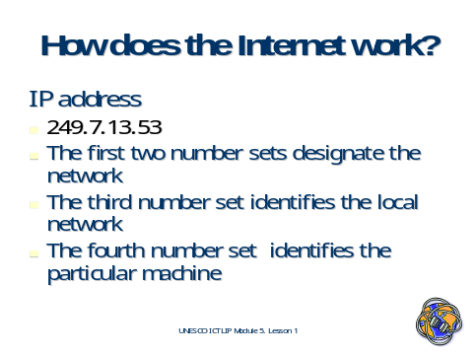
Slide 24

IP address

- 249.7.13.53 (Example IP address)
- The first two number sets designate the network
- The third number set identifies the local network
- The fourth number set identifies the particular machine

Activity 1-3
Read the following articles:
- TCP/IP Networking - What is TCP/IP? http://tutorials.beginners.co.uk/read/category/90/id/282
- Internet Protocols. http://www.rad.com/networks/1997/nettut/protocols.html
- Internet protocol and addressing. http://supportnet.merit.edu/m-intint/t-netbas/text/intpro.html
- Understanding IP Addressing. Webopedia. http://www.webopedia.com/DidYouKnow/2002/March/IPaddressing.html

Tip
View these sites:
- Networking Background. http://supportnet.merit.edu/m-intint/t-netbas/text/netbac.html
- Introduction to the Internet Protocols. http://oac3.hsc.uth.tmc.edu/staff/snewton/tcp-tutorial/index.html
- The Internet Protocol Part One: The Foundations. Shvetima Gulati. http://www.acm.org/crossroads/columns/connector/july2000.html

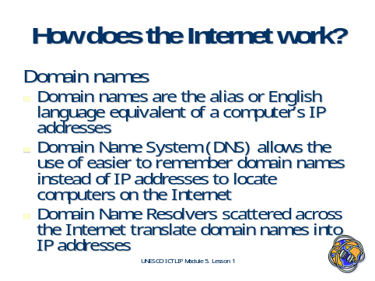
Slide 25

Domain names

Domain names are the alias or English- language equivalent of a computer’s IP address. The Domain Name System (DNS) allows the use of easier to remember domain names instead of IP addresses to locate computers on the Internet. Domain Name Resolvers scattered across the Internet translate domain names into IP addresses

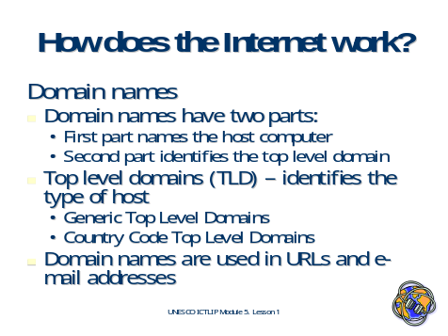
Slide 26

Domain names

Domain names have two parts: the first part names the host computer while the second part identifies the top level domain. Accordingly, there are two types of Top Level Domains (TLD): generic Top Level Domains and country code Top Level Domains. The TLD identifies the type of host; for example a domain that ends with .edu is an educational institution. Domain names are used in URLs and e-mail addresses.

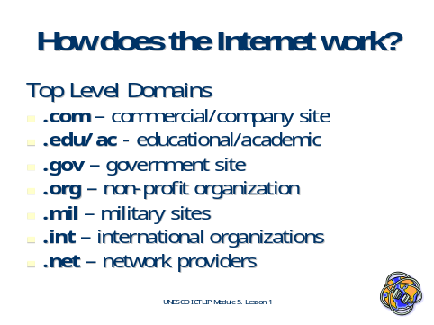
Slide 27

Top Level Domains

Only a few top-level domains are currently recognized, but this is changing. Here is a list of the domains generally accepted by all:
.edu -- educational site (usually a university or college)
.com -- commercial business site
.gov -- U.S. governmental/non-military site
.mil -- U.S. military sites and agencies
.net -- networks, internet service providers, organizations
.org -- U.S. non-profit organizations and others

Slide 28
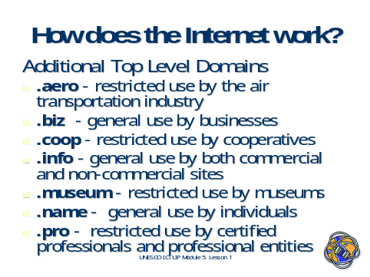

Additional Top Level Domains

In mid November 2000, the Internet Corporation for Assigned Names and Numbers (ICANN) voted to accept an additional seven new suffixes, which are expected to be made available to users :
.aero -- restricted use by air transportation industry
.biz -- general use by businesses
.coop -- restricted use by cooperatives
.info -- general use by both commercial and non-commercial sites
.museum -- restricted use by museums
.name -- general use by individuals
.pro -- restricted use by certified professionals and professional entities

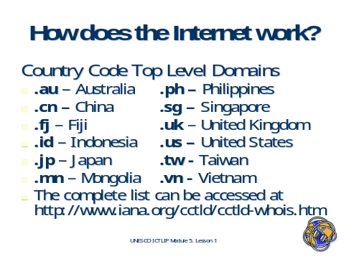
Slide 29

Country Code Top Level Domains

.au – Australia .ph – Philippines
.cn – China .sg – Singapore
.fj – Fiji .uk – United Kingdom
.id – Indonesia . .us – United States
.jp – Japan .tw - Taiwan
.mn – Mongolia .vn - Vietnam

The complete list can be accessed at http://www.iana.org/cctld/cctld-whois.htm

Note
Because the Internet was created in this country, "US" was not originally assigned to U.S. domain names; however, it is used to designate state and local government hosts, including many public schools.

Activity 1-4
Read the following articles:
- Introduction to Domain Name Service. http://supportnet.merit.edu/m-intint/t-domnam/text/intro1.html.
- IANA Domain Name Services. http://www.iana.org/domain-names.htm
- The Domain Name System: A Non-Technical Explanation – Why Universal Resolvability Is Important? InterNIC FAQ. http://www.internic.net/faqs/authoritative-dns.html

Tip
Read this article:
- The D-N-What: A Layman's Guide to the Domain Naming System. M.A. Dockter http://webservercompare.internet.com/dns/

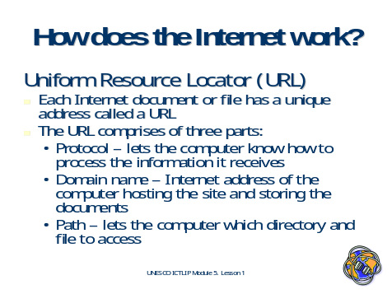
Slide 30

Uniform Resource Locator

A URL or Uniform Resource Locator is the unique address of a given webpage. Knowing the URL allows you to locate a given webpage. Much like a house address, the URL consists of several parts: the protocol, the domain name and the path.
- Protocol – lets the computer know how to process the information it receives
- Domain name – Internet address of the computer hosting the site and storing the documents
- Path – lets the computer know which directory and file to access

Slide 31
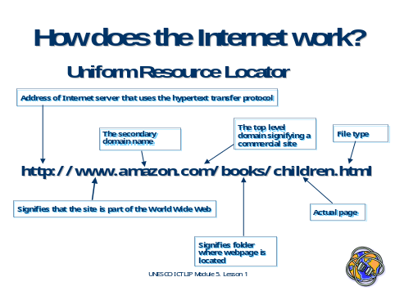

Figure1: Anatomy of a URL

Slide 32

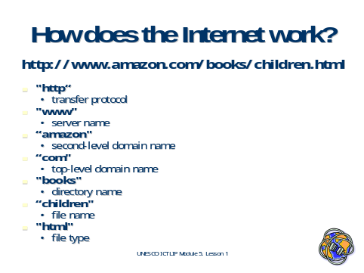

Uniform Resource Locator

In the example http://www.amazon.com/books/children.html
- "http“ - hypertext transfer protocol
- "www" - world wide web server name
- “amazon" - second-level domain name
- “com" - top-level domain name
- "books" - directory name
- “children" - file name
- "html" - file type

Activity1 -5
Visit these sites:
- Learn the NET: Anatomy of a URL. http://www.learnthenet.com/english/web/110www.htm
- The Anatomy of a URL (Uniform Resource Locator). http://www2.widener.edu/Wolfgram-Memorial-Library/pyramid/ wwwanato.htm

Slide 33
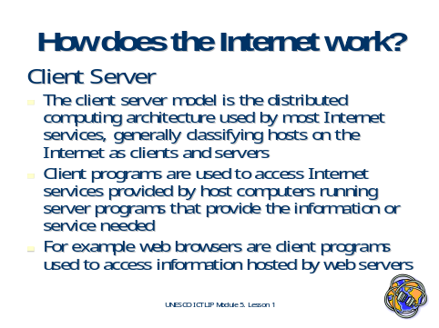

Client Server

The client server model is the distributed computing architecture used by most Internet services, generally classifying hosts on the Internet as clients and servers. Client computers use client programs to access Internet services provided by host computers (servers) running server programs that provide the information or service needed. For example, web browsers are client programs used to access information hosted by web servers. Each Internet service requires a specific client program; however most of these services can now be accessed by simply using a web browser.

Activity 1-6
Read these articles:
- Introduction to Client/Server Networking: A proven approach to distributed computing http://compnetworking.about.com/library/weekly/aa050201a.htm
- Client/Server Software Architectures-An Overview. http://www.sei.cmu.edu/str/descriptions/clientserver_body.html
- What is client/server computing? http://www.apinforma.com/biblio/online/internic/cliensrv/sld01.html

Tip
Visit these sites:
- Howstuffworks "How Web Servers and the Internet Work. http://www.howstuffworks.com/web-server.htm
- Client-server architecture: bringing order to the bramble bush http://www.ssa-lawtech.com/wp/wp3-5.htm
- Client/Server Fundamentals http://www.networkcomputing.com/netdesign/1005part1a.html
- Network Solutions 15 Minute series http://www.apinforma.com/biblio/online/internic/

